Unreal Engine Map Load Times Automation Test

**Creating a Complex Automation Test Class**

* 1. Open Unreal Engine.
  2. Select "C++ Classes" folder in the Content Browser.
  3. Right Click and add a new C++ class.
  4. Select None for the parent class.
  5. Select "Private".
  6. Input the class name with the following format "*FeatureBeingTested*Test.cpp".

e.g. MapLoadTimesTest.cpp

* 1. Add "Tests/" to the end of the file path.
  2. Once compiling has finished close Unreal Engine.
  3. Open the projects source folder and navigate to the new class.
  4. Delete the header file and rename the cpp file to Return to the project folder and delete the following folders/file:
     1. .vs
     2. Binaries
     3. Intermediate
     4. Saved
     5. "*ProjectName*.sln"
  5. Right click the "*ProjectName*.uproject" file and select "Generate Visual Studio Project Files".
  6. Once completed open the "*ProjectName*.sln" file.
  7. Build the vs project by pressing F5.
  8. Open the "*FeatureBeingTested*Test.cpp" file in visual studio.

**Writing a Complex Automation Test**

* 1. Delete everything that in the "*FeatureBeingTested*Test.cpp" file.
  2. At the top of the file, you will need to add any includes that are required for the test to run.
     1. The Class you are testing, e.g. #include “Enemy.h”
  3. Start with the IMPLEMENT_COMPLEX_AUTOMATION_TEST Macro.
     1. The first section of the Macro is the test class name.
     2. The second section is where the test will be located in the session front end.
     3. The third section is for the [EAutomationTestFlags](https://docs.unrealengine.com/4.26/en-US/API/Runtime/Core/Misc/EAutomationTestFlags__Type/).







* 1. Write a "GetTests" with the parameters: "TArray<FString>& OutBeautifiedNames” and “TArray<FString>& OutTestCommands".



* 1. Inside the "GetTests" function we gather together everything that will have test run on, for this example we will be getting all the map names to run a test on each map.    
     To do this we will get all the packagefiles, iterate through them to check which have the .umap extention and add them to TArray parameters.

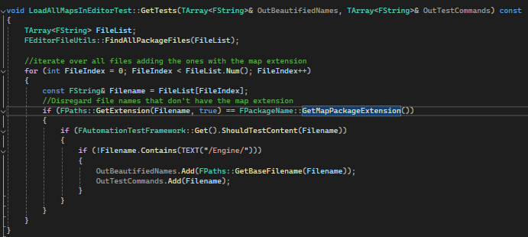

* 1. Next in the runTest function we will get the map name from the parameters and set a double for maploadstarttime to 0. Then set the maploadstarttime to the platform time and load the map.
  2. Finally, we can log the current platformtime minus the maploadstarttime to give us the amount of time for the map to load.

